Composite Solids with Flat and Mixed Curved Surfaces

Definition
# Source: AI Source: Provided by: [Data Path: Persons Table -> ID Column: 1, Name_En Column: Motasem Essam] -> From: [ChatGPT] on [7/25/2026]
Composite Solids with Flat and Mixed Curved Surfaces are three-dimensional geometric solids formed by combining two or more solid components whose external boundaries include both flat planar surfaces and multiple types of curved surfaces.
These composite solids combine planar faces, such as squares, rectangles, triangles, and circles, with different curved surfaces, such as cylindrical, conical, spherical, hemispherical, ellipsoidal, and toroidal surfaces.
They may be formed by combining prisms, cubes, cylinders, cones, spheres, hemispheres, and other geometric solids.
The resulting structure can contain several different curved surface types within one composite solid.

Simple Definition
# Source: AI Source: Provided by: [Data Path: Persons Table -> ID Column: 1, Name_En Column: Motasem Essam] -> From: [ChatGPT] on [7/25/2026]
A composite solid with flat and mixed curved surfaces is a 3D shape that combines flat faces with two or more different types of curved surfaces.

Geometric Representation
# Source: AI Source: Provided by: [Data Path: Persons Table -> ID Column: 1, Name_En Column: Motasem Essam] -> From: [ChatGPT] on [7/25/2026]
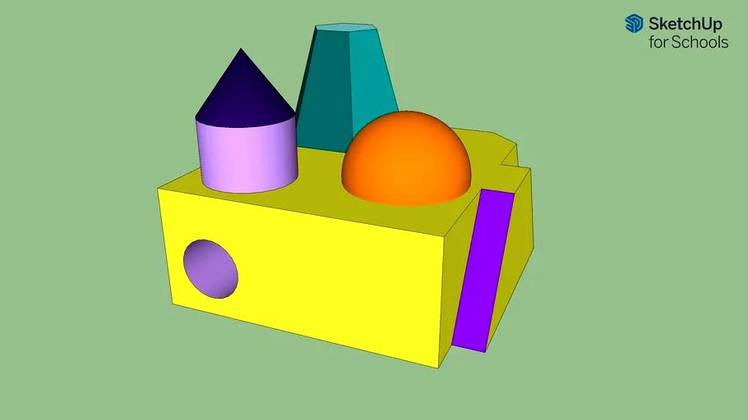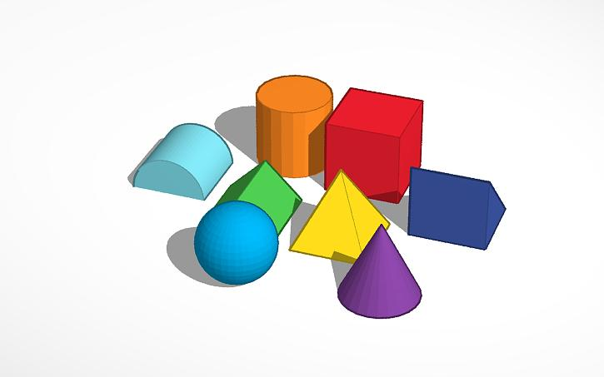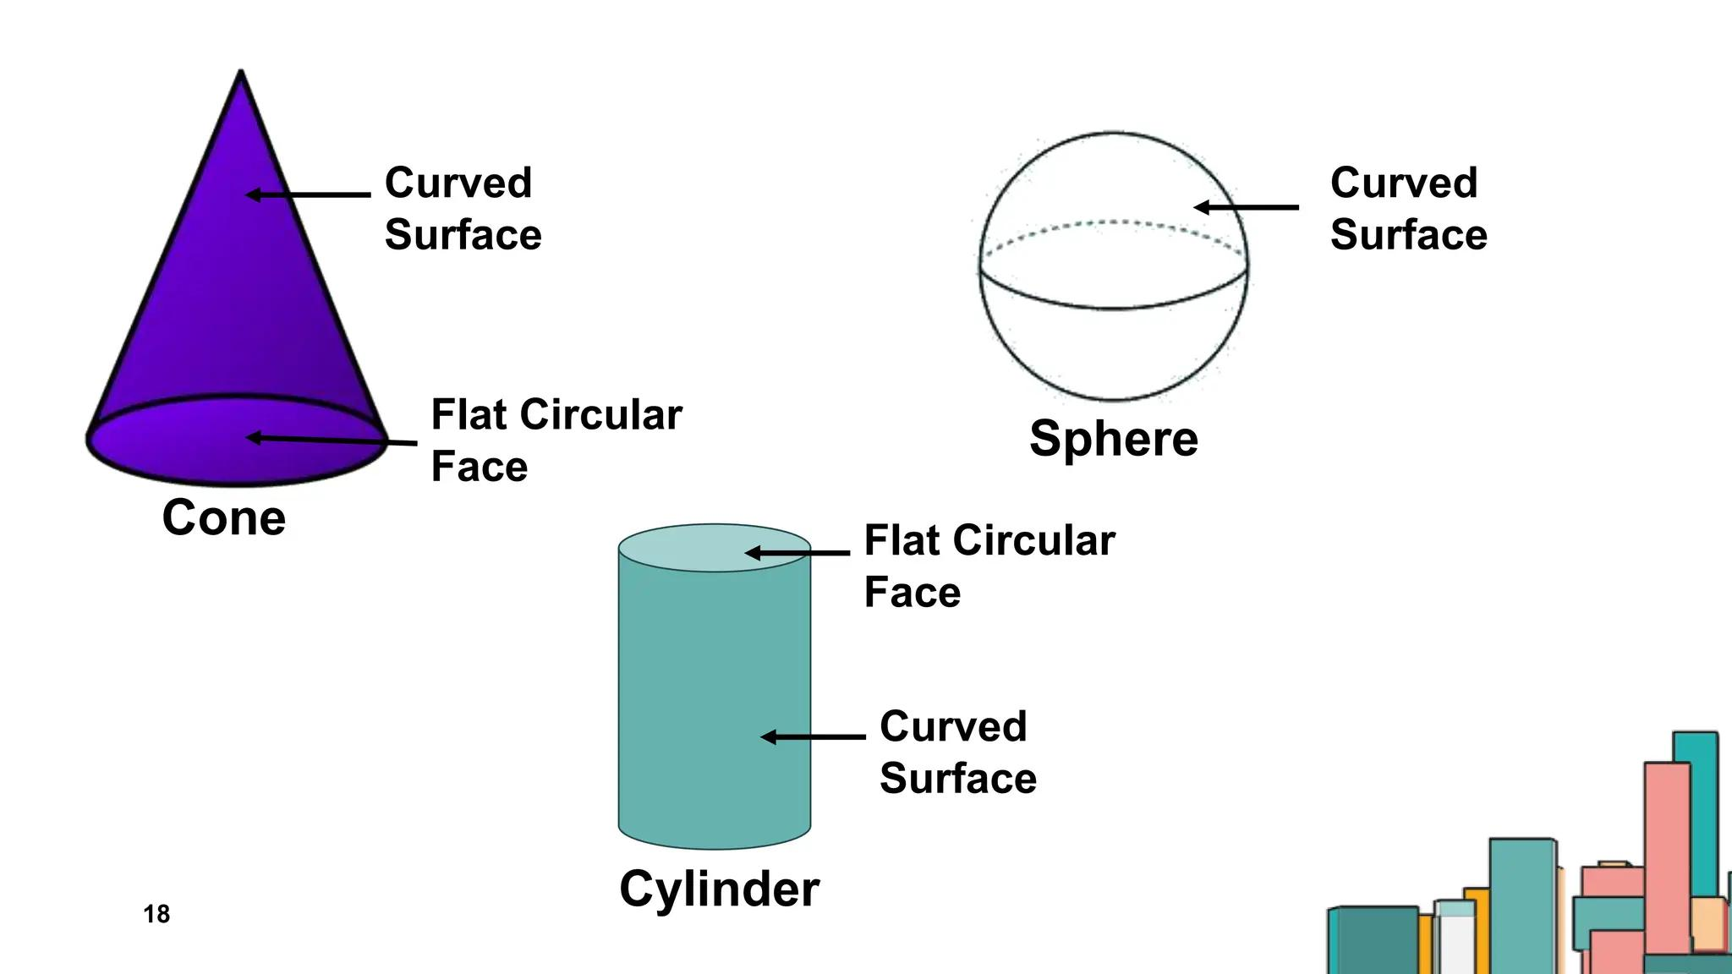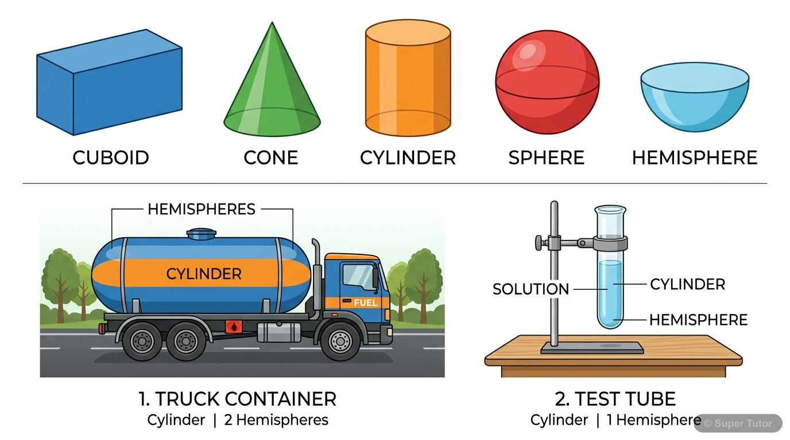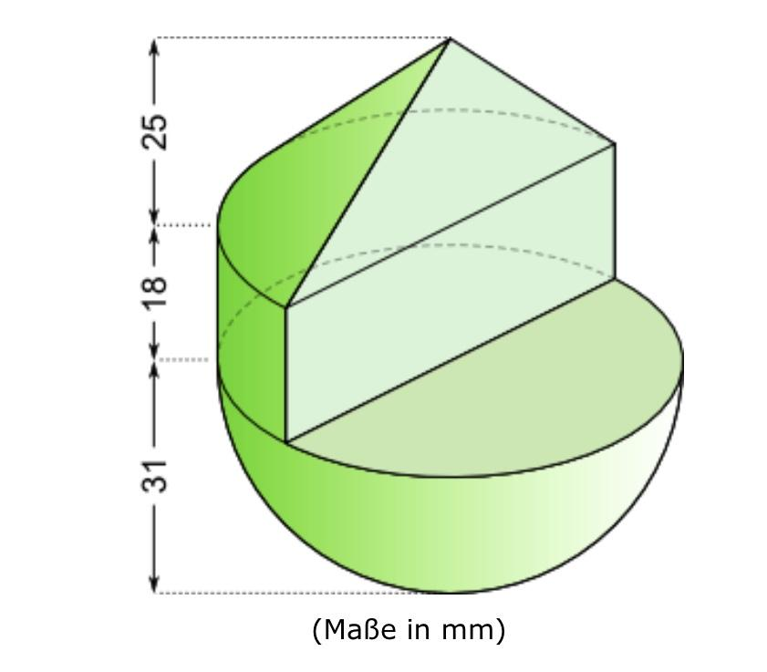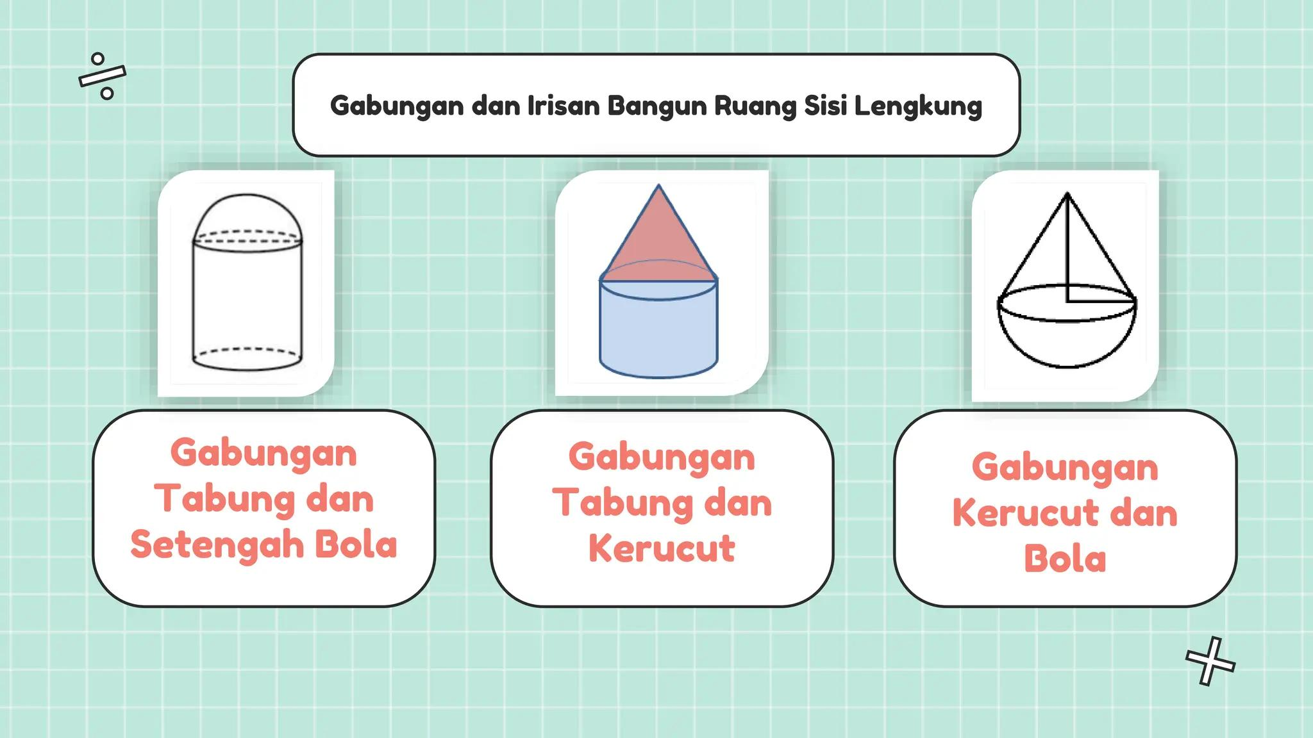
The main surface types are:
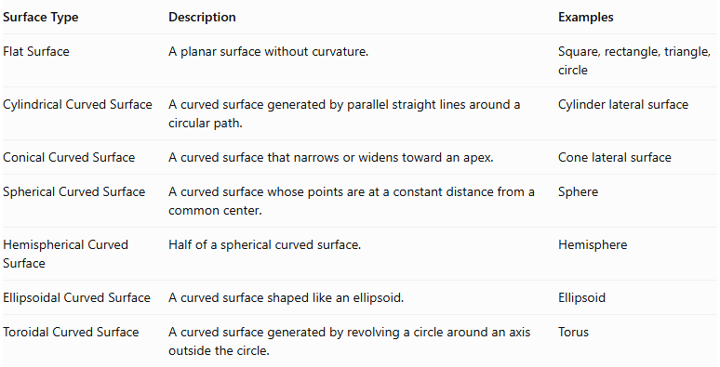
Surface Type | Description | Examples
Flat Surface | A planar surface without curvature. | Square, rectangle, triangle, circle
Cylindrical Curved Surface | A curved surface generated by parallel straight lines around a circular path. | Cylinder lateral surface
Conical Curved Surface | A curved surface that narrows or widens toward an apex. | Cone lateral surface
Spherical Curved Surface | A curved surface whose points are at a constant distance from a common center. | Sphere
Hemispherical Curved Surface | Half of a spherical curved surface. | Hemisphere
Ellipsoidal Curved Surface | A curved surface shaped like an ellipsoid. | Ellipsoid
Toroidal Curved Surface | A curved surface generated by revolving a circle around an axis outside the circle. | Torus
Important: A composite solid may contain more than two types of curved surfaces. The classification depends on the actual exposed surfaces, not merely on the names of the component solids.

Main Classification
# Source: AI Source: Provided by: [Data Path: Persons Table -> ID Column: 1, Name_En Column: Motasem Essam] -> From: [ChatGPT] on [7/25/2026]
Composite solids with flat and mixed curved surfaces can be classified according to the combinations of curved surface types included in their structures.

Flat and Cylindrical-Conical Surfaces
# Source: AI Source: Provided by: [Data Path: Persons Table -> ID Column: 1, Name_En Column: Motasem Essam] -> From: [ChatGPT] on [7/25/2026]
These solids combine flat surfaces with both cylindrical and conical curved surfaces.
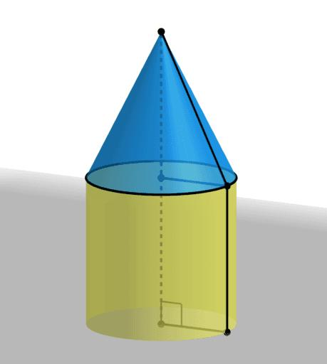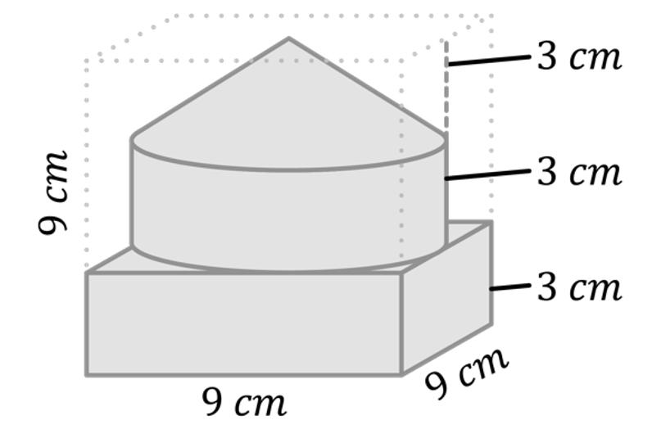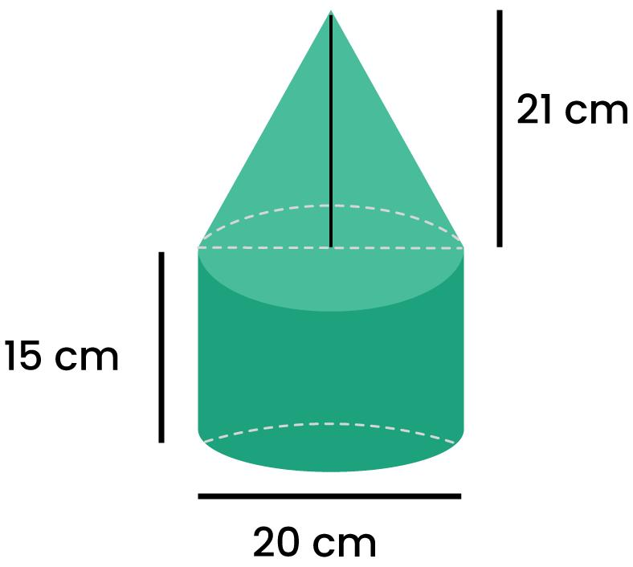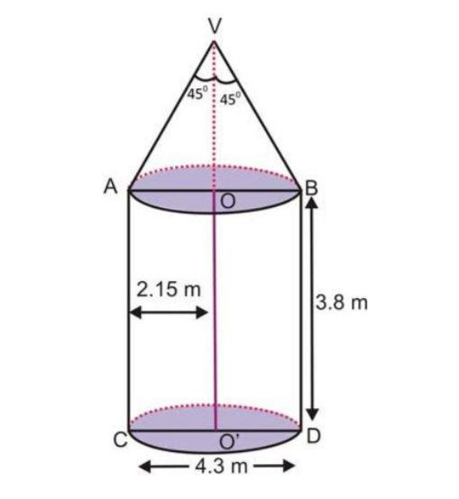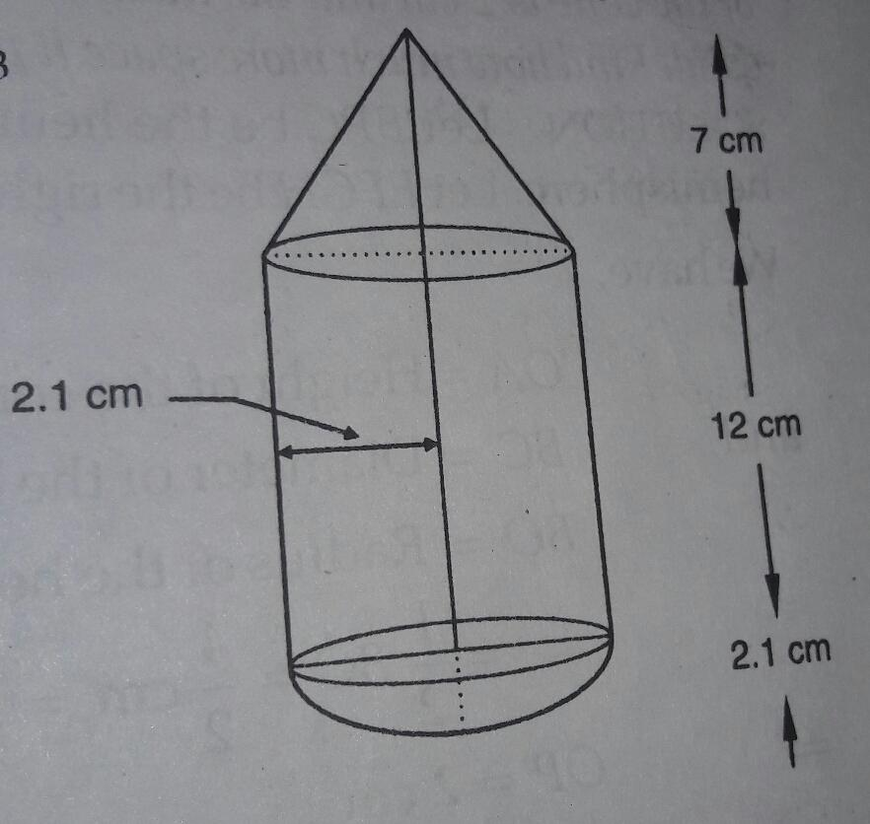
Examples:
- Cylinder with a Cone
- Cylinder with a Conical Frustum
- Rectangular Prism with a Cylinder and a Cone
- Multiple Cylinders with Conical Extensions

Flat and Cylindrical-Spherical Surfaces
# Source: AI Source: Provided by: [Data Path: Persons Table -> ID Column: 1, Name_En Column: Motasem Essam] -> From: [ChatGPT] on [7/25/2026]
These solids combine flat surfaces with cylindrical and spherical curved surfaces.
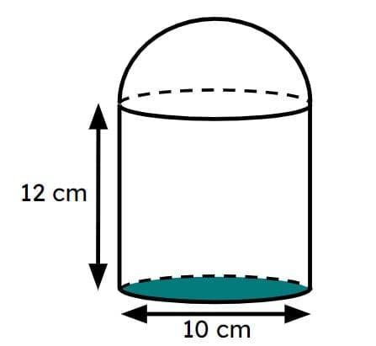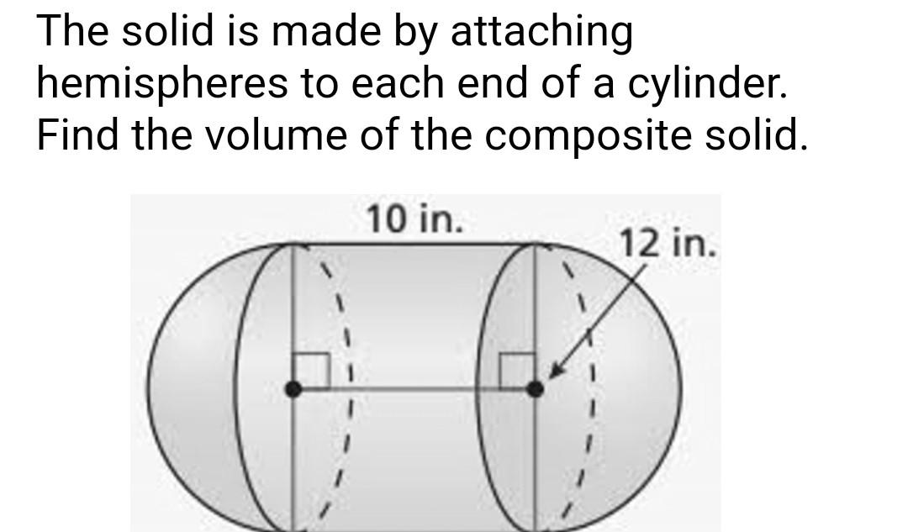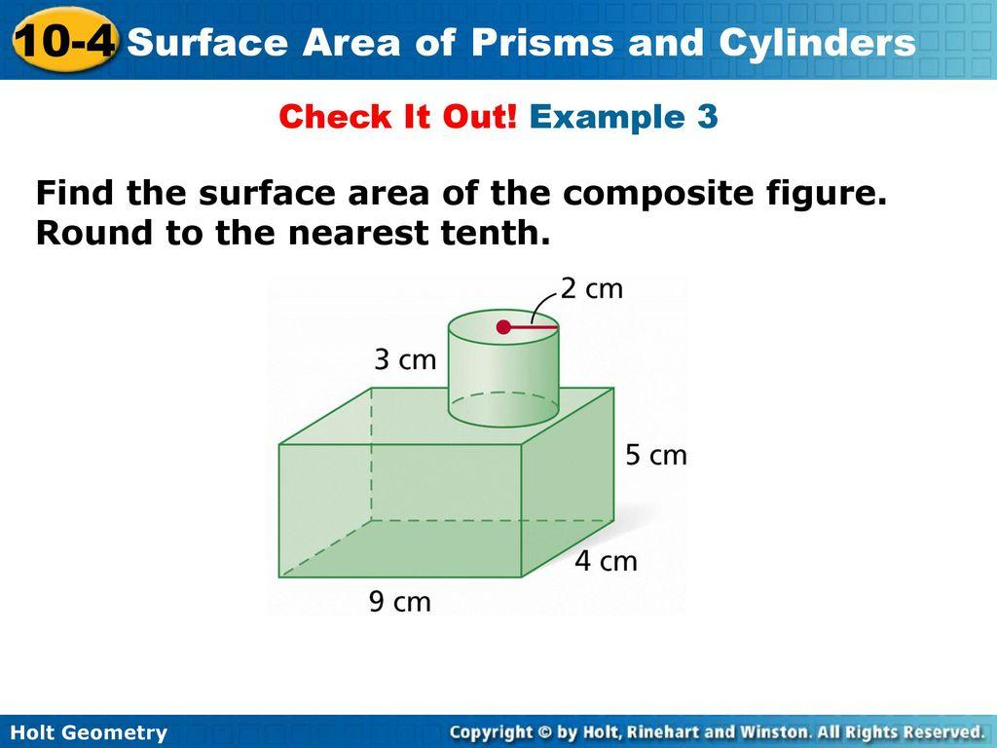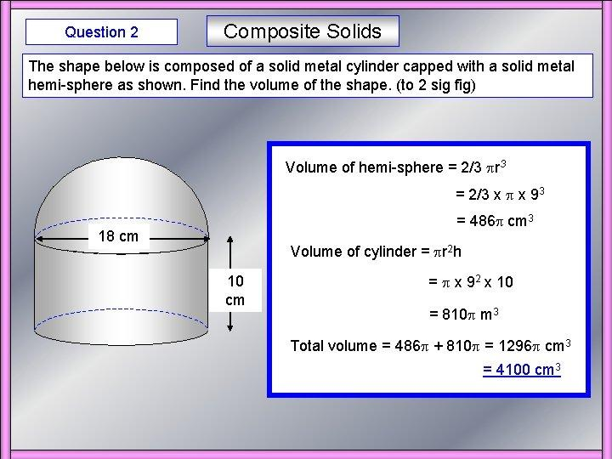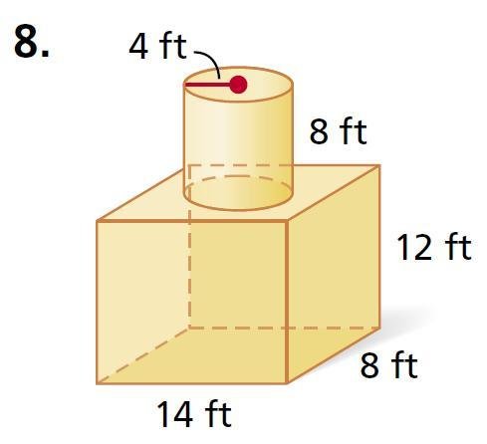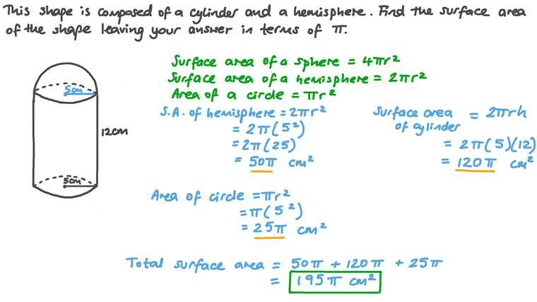
Examples:
- Cylinder with a Sphere
- Cylinder with a Hemisphere
- Rectangular Prism with a Cylinder and a Sphere
- Cylindrical Body with Spherical Ends

Flat and Cylindrical-Hemispherical Surfaces
# Source: AI Source: Provided by: [Data Path: Persons Table -> ID Column: 1, Name_En Column: Motasem Essam] -> From: [ChatGPT] on [7/25/2026]
These solids combine flat surfaces with cylindrical and hemispherical curved surfaces.
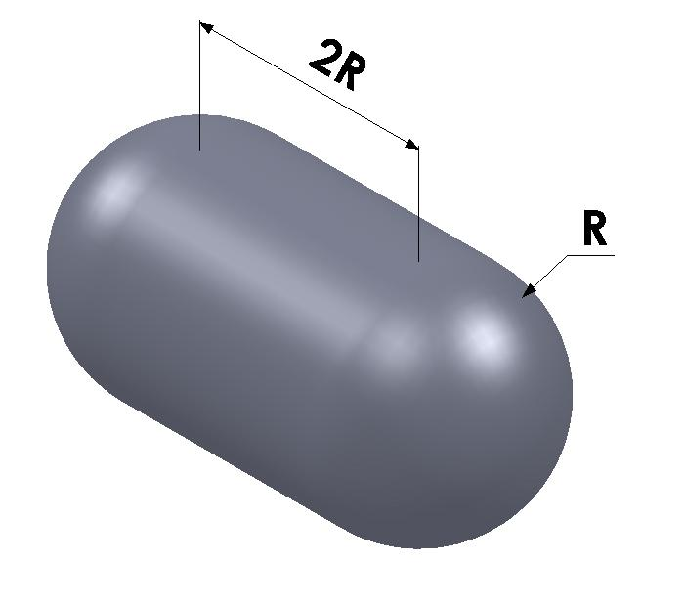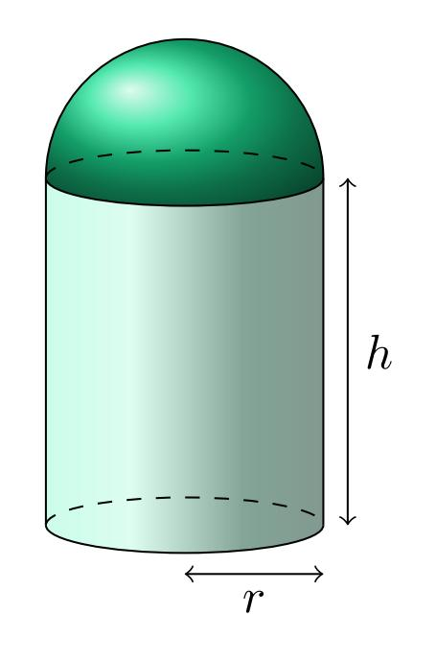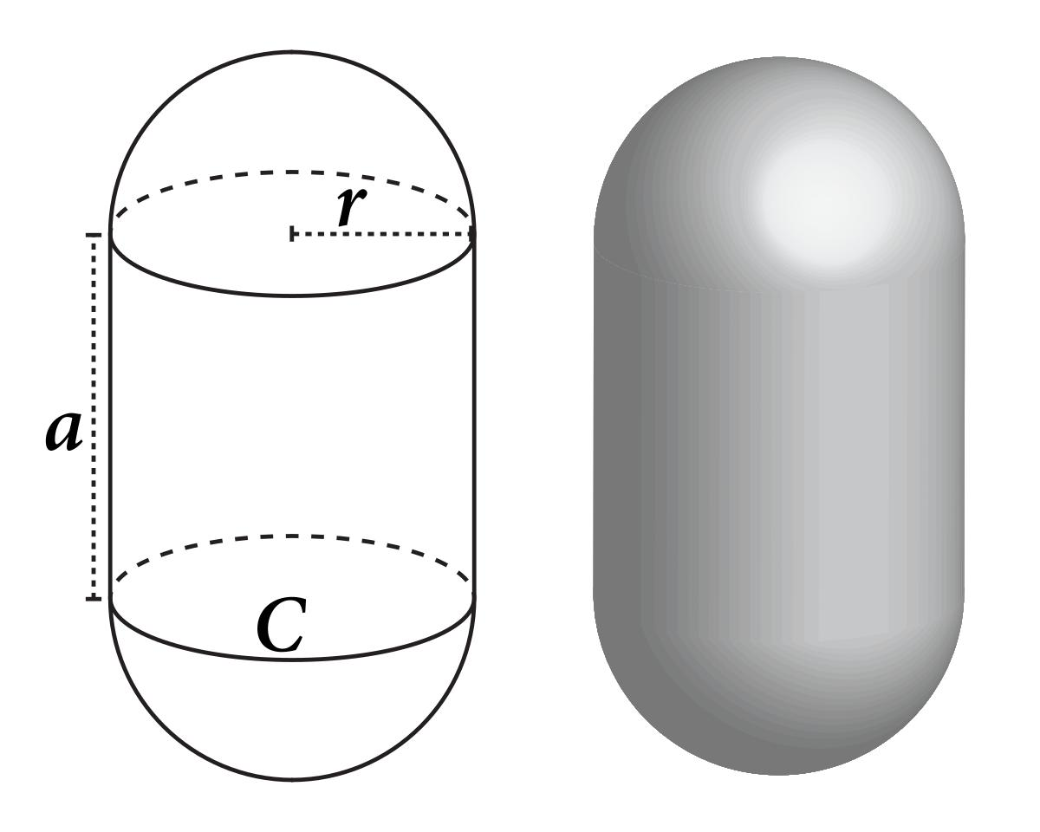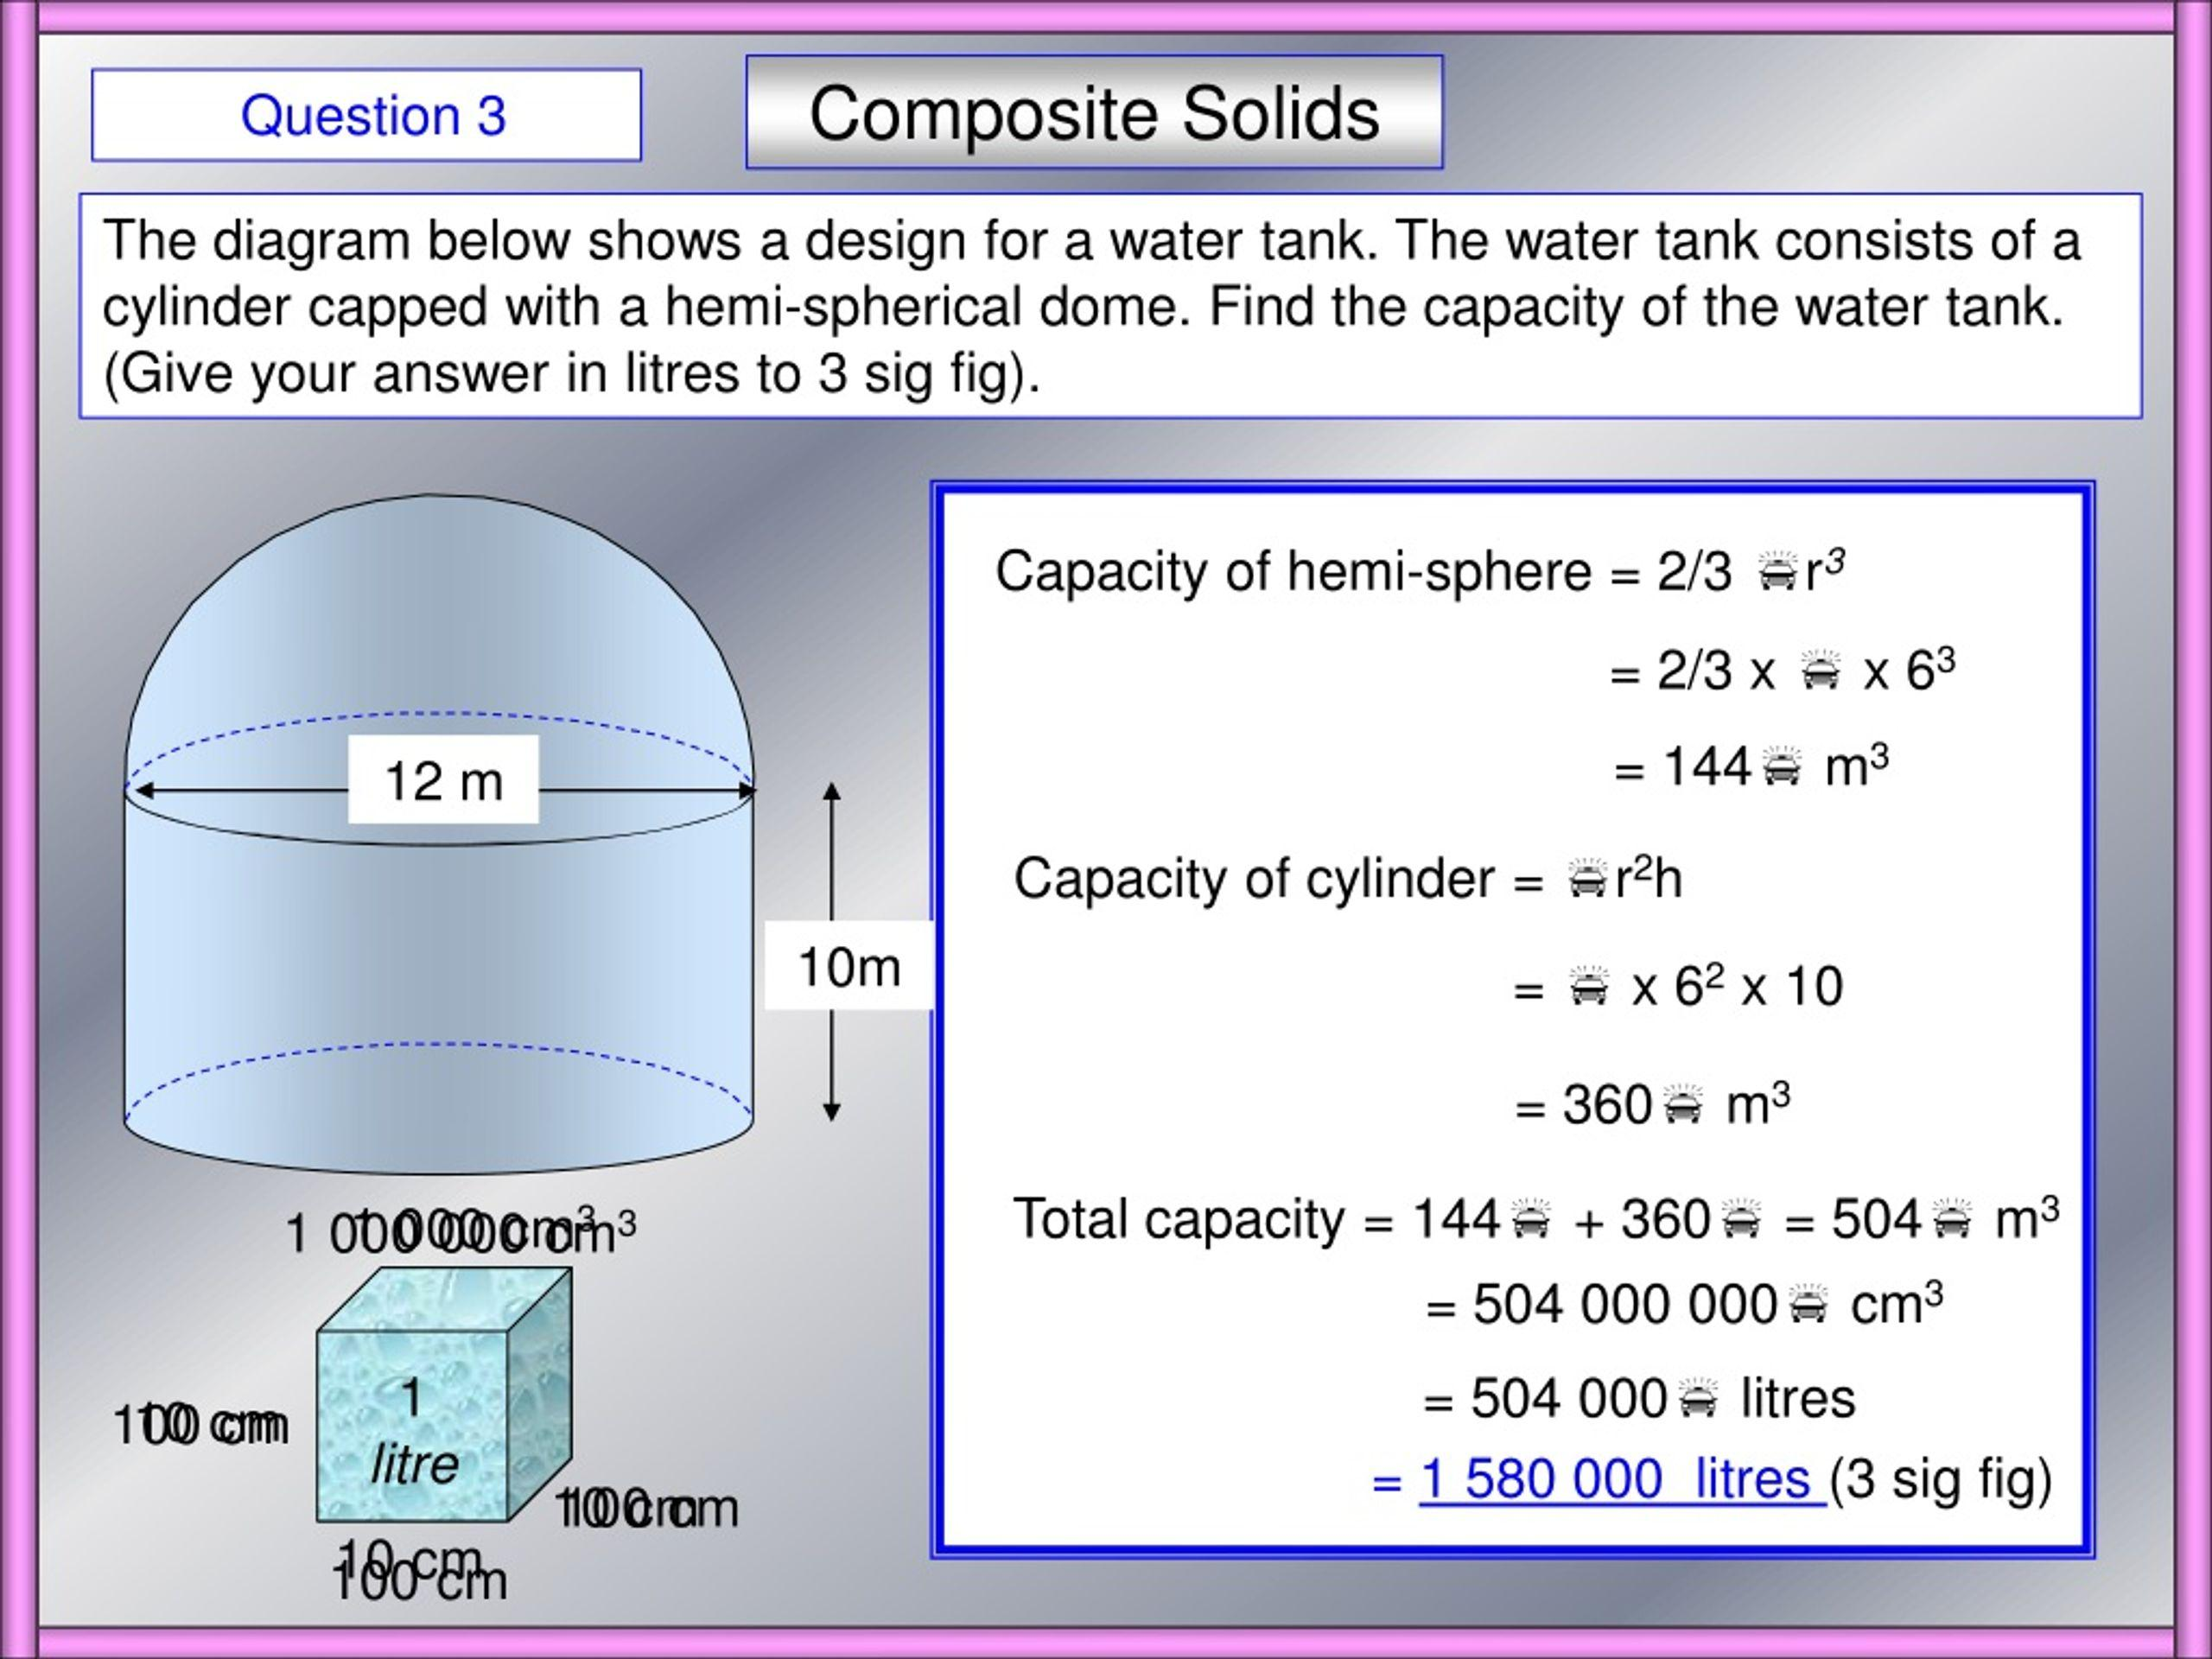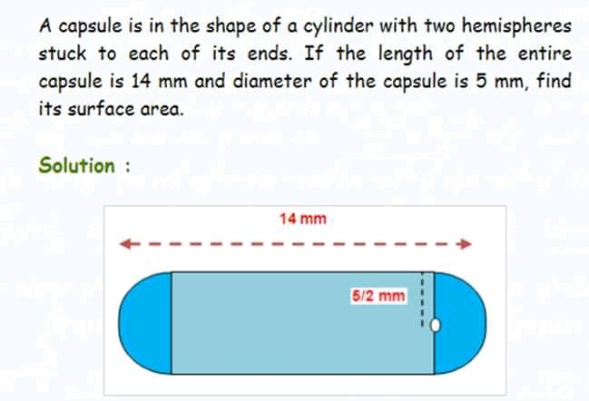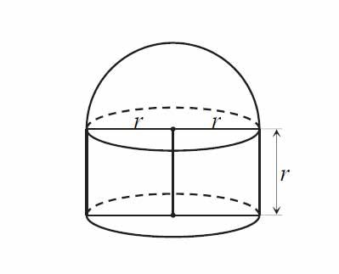
Examples:
- Cylinder with Two Hemispherical Ends
- Cylinder with a Hemispherical Top and Flat Bottom
- Rectangular Prism with a Cylindrical Component and Hemisphere
- Cylindrical Body with Multiple Hemispherical Extensions

Flat and Conical-Spherical Surfaces
# Source: AI Source: Provided by: [Data Path: Persons Table -> ID Column: 1, Name_En Column: Motasem Essam] -> From: [ChatGPT] on [7/25/2026]
These solids combine flat surfaces with conical and spherical curved surfaces.
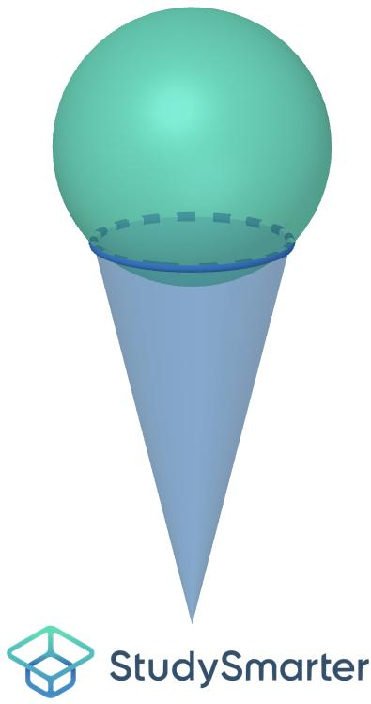
Examples:
- Cone with a Sphere
- Cone with a Spherical Cap
- Rectangular Prism with a Cone and Sphere
- Conical Component with Spherical Extensions

Flat and Conical-Hemispherical Surfaces
# Source: AI Source: Provided by: [Data Path: Persons Table -> ID Column: 1, Name_En Column: Motasem Essam] -> From: [ChatGPT] on [7/25/2026]
These solids combine flat surfaces with conical and hemispherical curved surfaces.
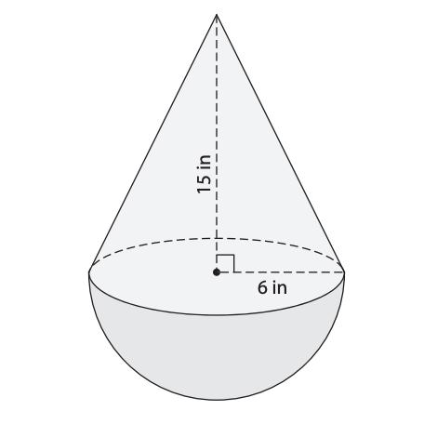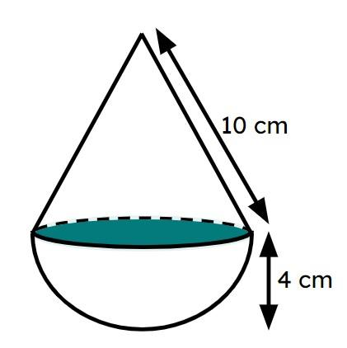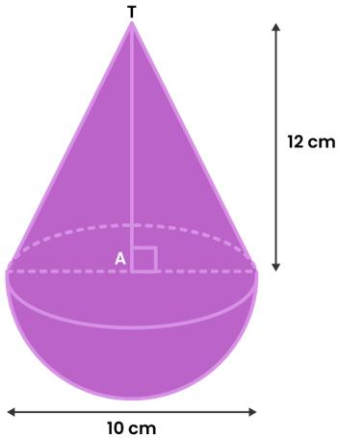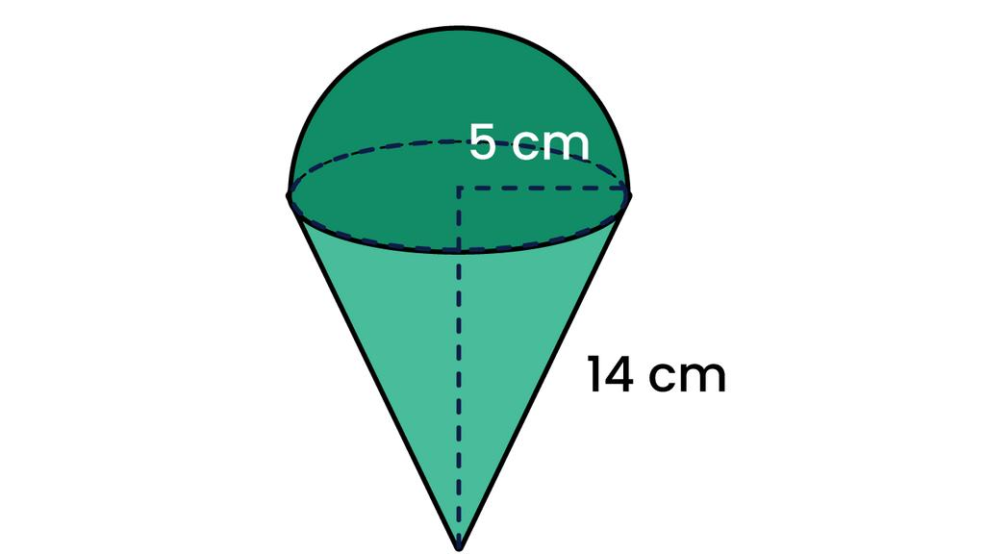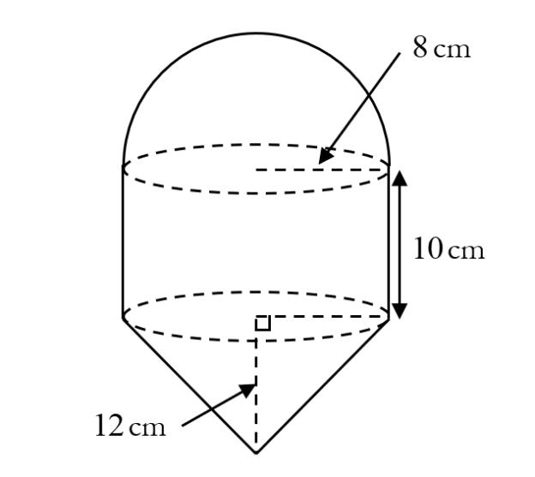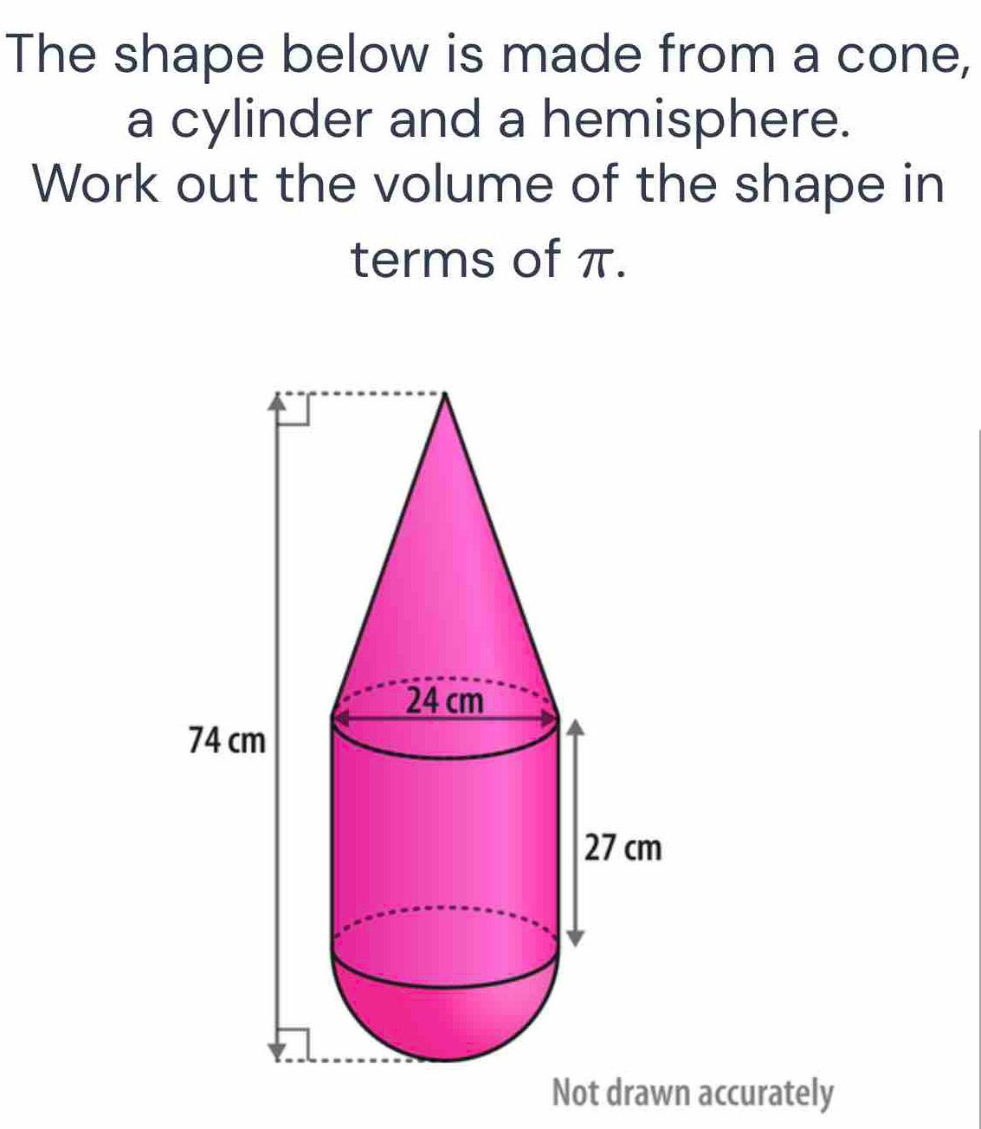
Examples:
- Cone with a Hemisphere
- Conical Frustum with a Hemisphere
- Rectangular Prism with a Cone and Hemisphere
- Multiple Cones with Hemispherical Components

Flat and Spherical-Hemispherical Surfaces
# Source: AI Source: Provided by: [Data Path: Persons Table -> ID Column: 1, Name_En Column: Motasem Essam] -> From: [ChatGPT] on [7/25/2026]
These solids combine flat surfaces with spherical and hemispherical curved surfaces.
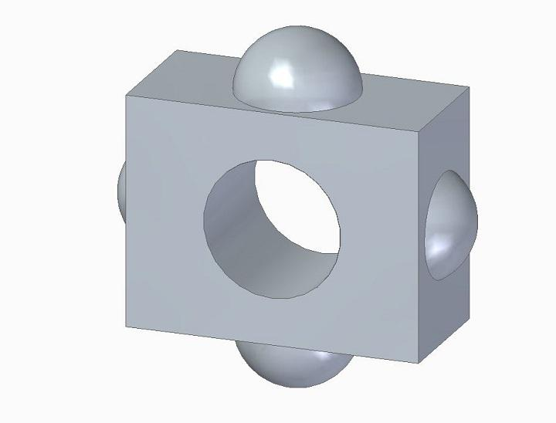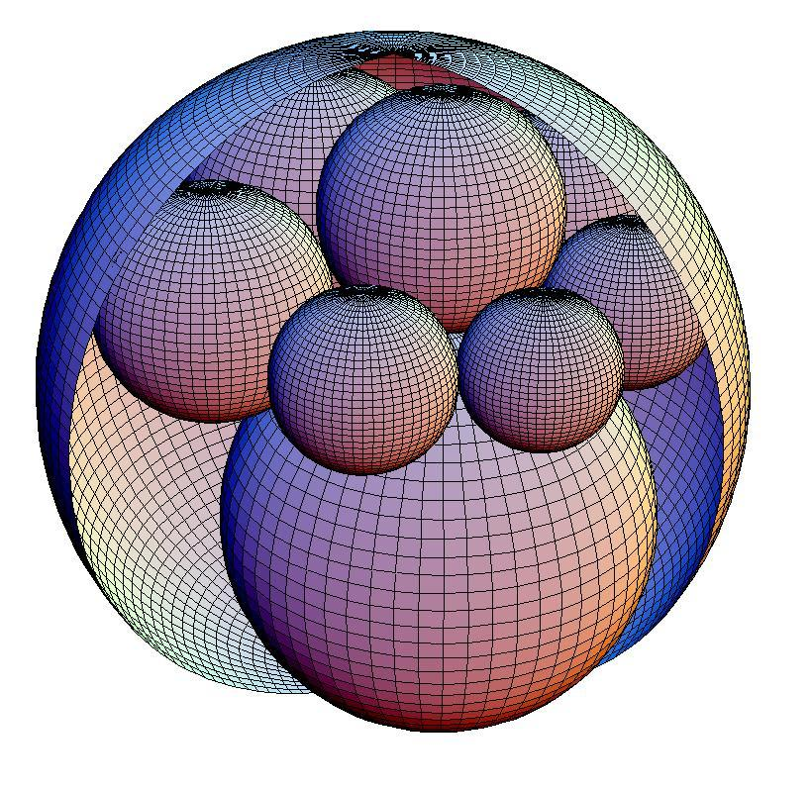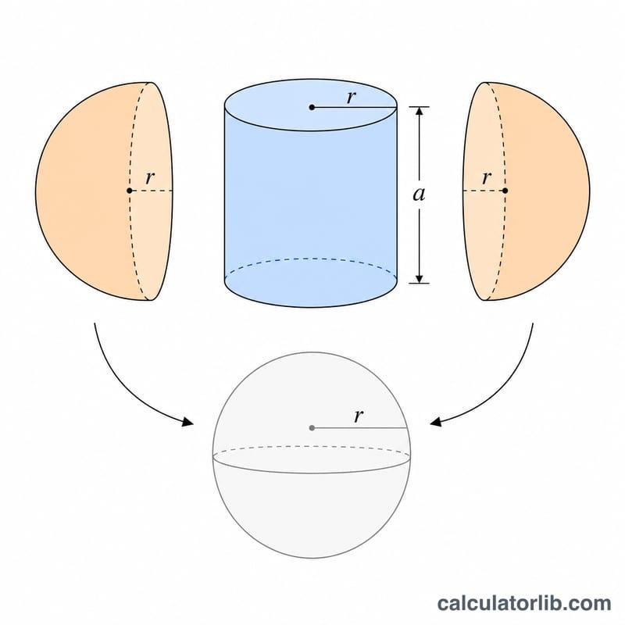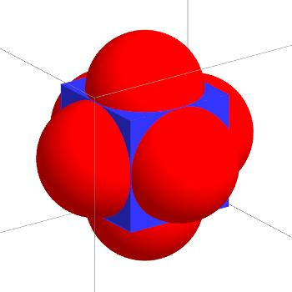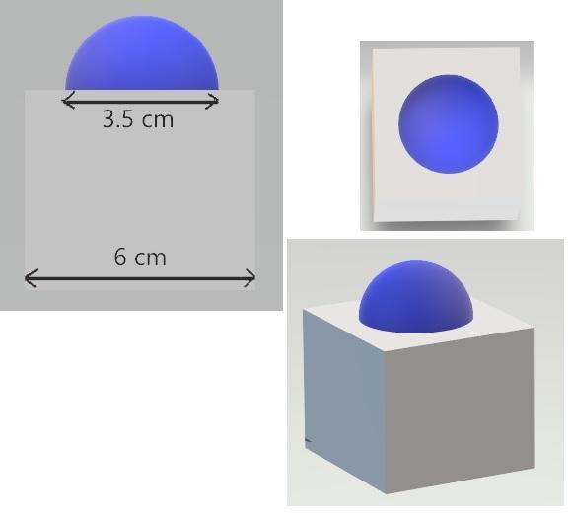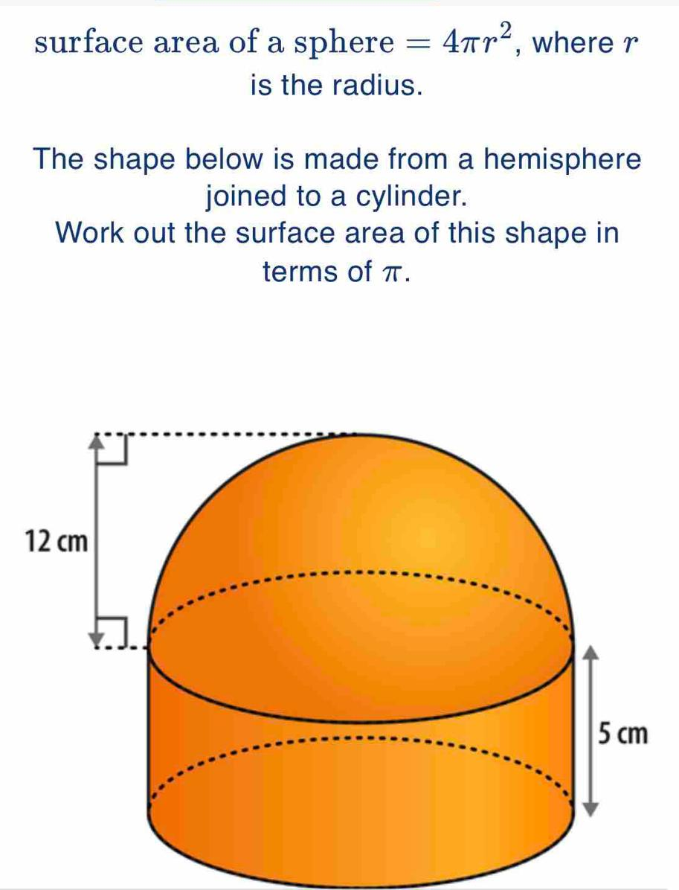
Examples:
- Sphere with a Hemisphere
- Two Spheres with a Hemisphere
- Rectangular Prism with Spherical and Hemispherical Components
- Multiple Spherical Components with Different Radii

Flat and Cylindrical-Conical-Spherical Surfaces
# Source: AI Source: Provided by: [Data Path: Persons Table -> ID Column: 1, Name_En Column: Motasem Essam] -> From: [ChatGPT] on [7/25/2026]
These solids combine flat surfaces with cylindrical, conical, and spherical curved surfaces.
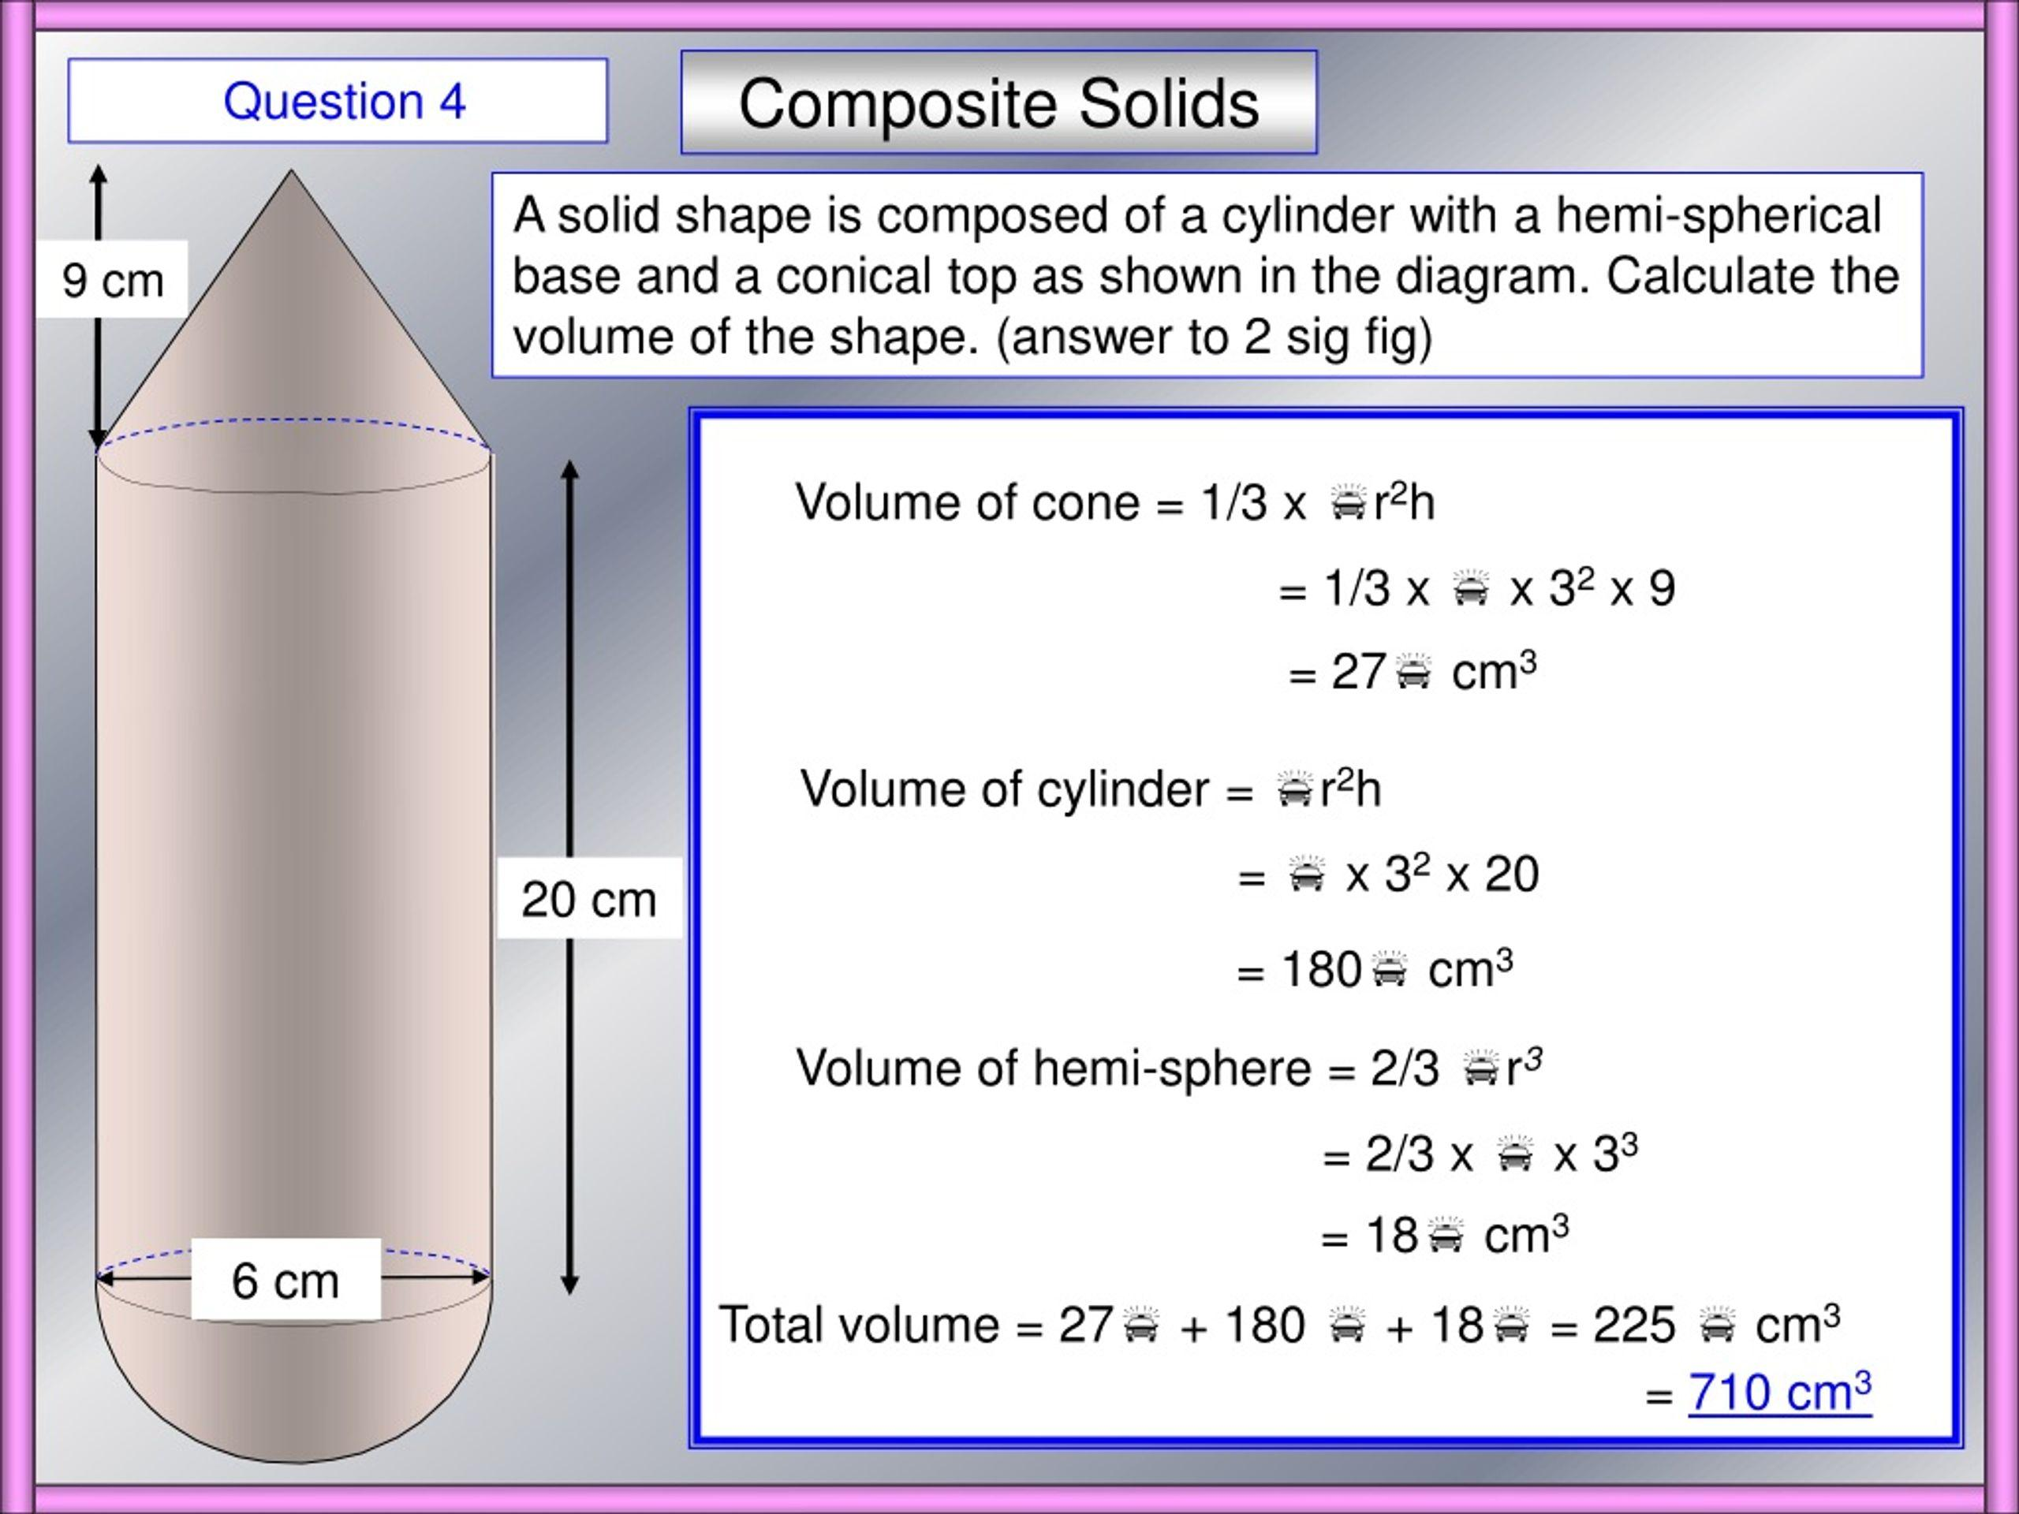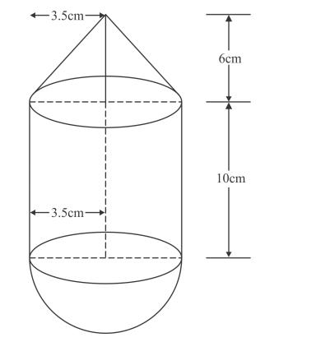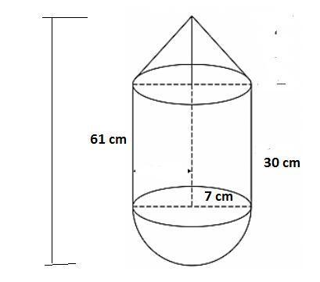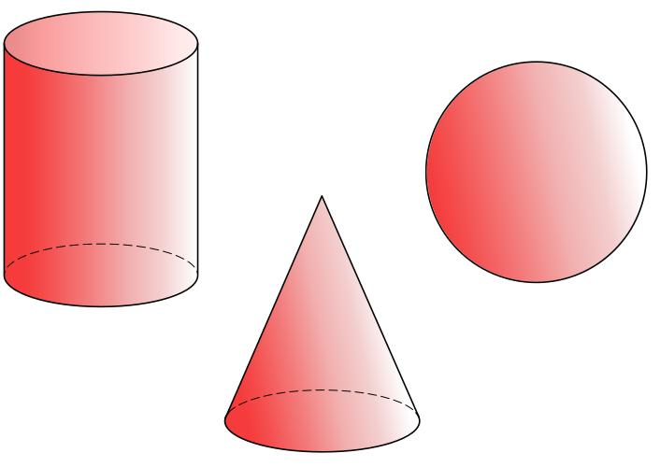
Examples:
- Cylinder with a Cone and Sphere
- Cylinder with a Conical Top and Spherical Bottom
- Rectangular Prism with Cylinder, Cone, and Sphere
- Multiple Cylindrical, Conical, and Spherical Components

Flat and Multiple Curved Surfaces
# Source: AI Source: Provided by: [Data Path: Persons Table -> ID Column: 1, Name_En Column: Motasem Essam] -> From: [ChatGPT] on [7/25/2026]
These solids combine flat surfaces with three or more different types of curved surfaces.
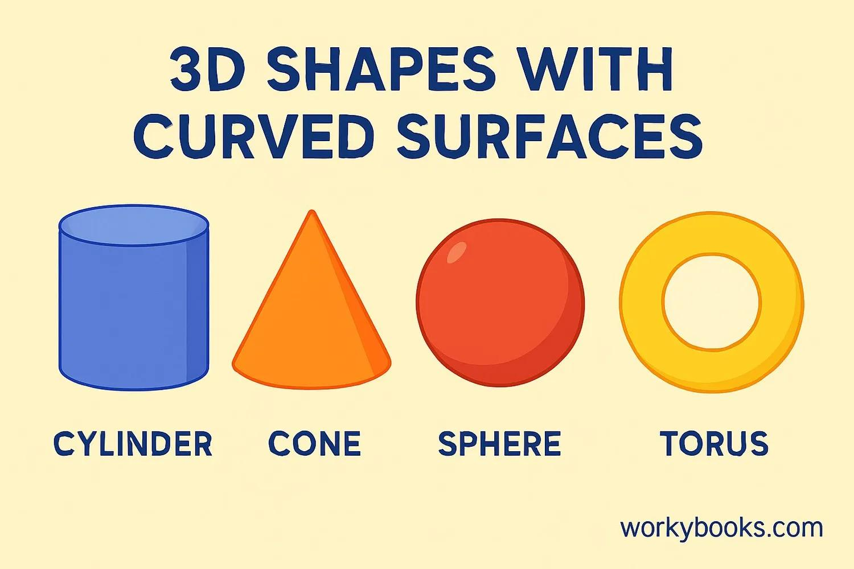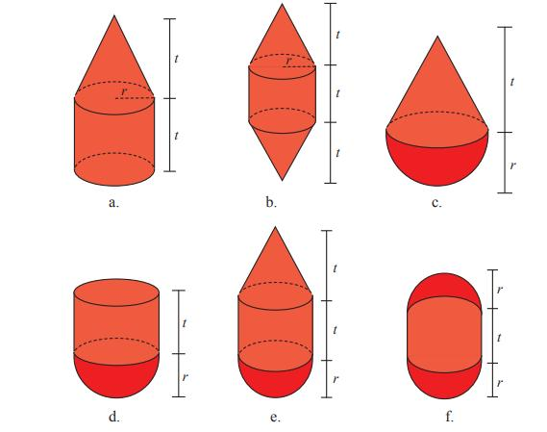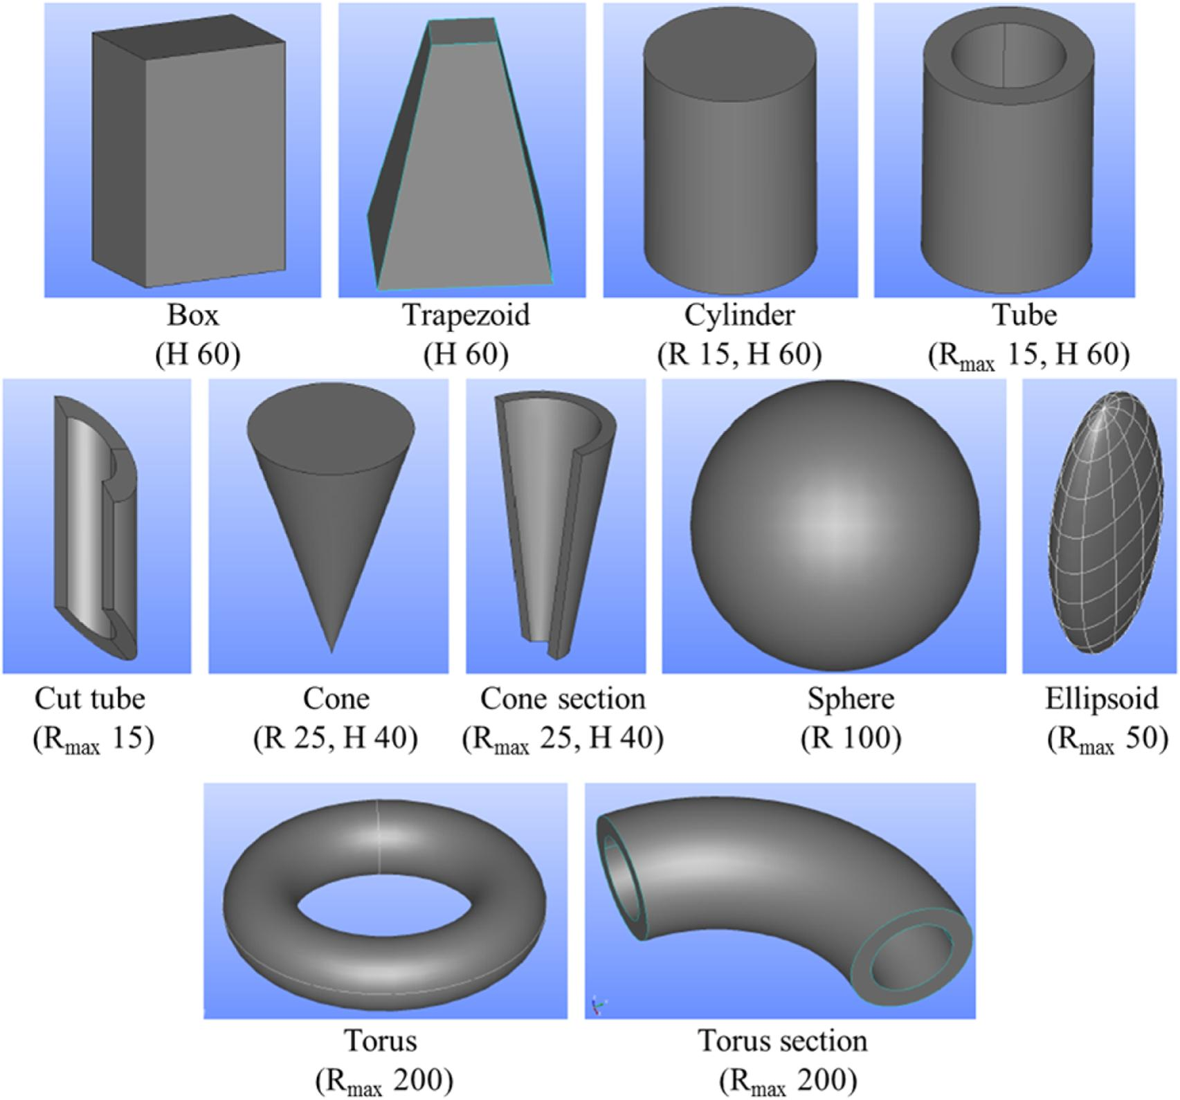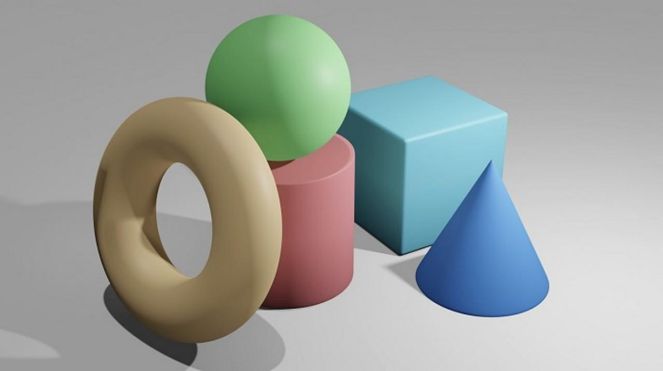
Examples:
- Cylinder, Cone, and Hemisphere with a Rectangular Prism
- Sphere, Cylinder, and Conical Frustum with a Cube
- Ellipsoid, Cylinder, and Cone with Flat-Faced Components
- Torus, Cylinder, and Sphere with Prismatic Components
- Complex Mixed-Shape Composite Solids

Classification by Curved Surface Combination
# Source: AI Source: Provided by: [Data Path: Persons Table -> ID Column: 1, Name_En Column: Motasem Essam] -> From: [ChatGPT] on [7/25/2026]
Another way to classify these solids is by identifying the different curved surfaces present in the same composite structure.
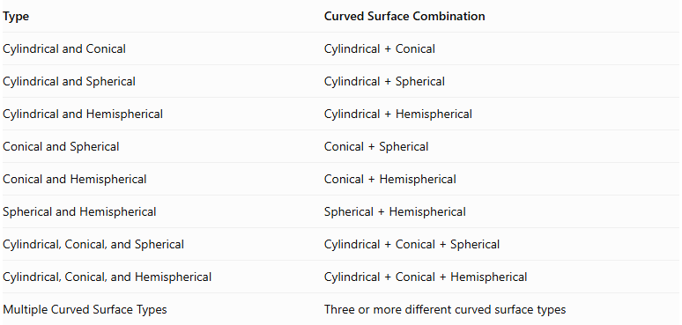
Type | Curved Surface Combination
Cylindrical and Conical | $$Cylindrical+Conical$$
Cylindrical and Spherical | $$Cylindrical+Spherical$$
Cylindrical and Hemispherical | $$Cylindrical+Hemispherical$$
Conical and Spherical | $$Conical+Spherical$$
Conical and Hemispherical | $$Conical+Hemispherical$$
Spherical and Hemispherical | $$Spherical+Hemispherical$$
Cylindrical, Conical, and Spherical | $$Cylindrical+Conical+Spherical$$
Cylindrical, Conical, and Hemispherical | $$Cylindrical+Conical+Hemispherical$$
Multiple Curved Surface Types | Three or more different curved surface types

Classification by Component Arrangement
# Source: AI Source: Provided by: [Data Path: Persons Table -> ID Column: 1, Name_En Column: Motasem Essam] -> From: [ChatGPT] on [7/25/2026]
- Stacked Arrangement: Components with different curved surfaces are placed above or below one another.
- End-to-End Arrangement: Components are connected consecutively along a common direction.
- Side-Attached Arrangement: Curved components are attached to the sides of flat-faced or curved components.
- Coaxial Arrangement: Cylindrical and conical components share a common central axis.
- Nested Arrangement: One component is placed inside another, creating internal and external curved boundaries.
- Surrounding Arrangement: One curved component partially or completely surrounds another component.
- Multi-Directional Arrangement: Components extend in different directions from a central component.

Mathematical Properties and Formulas
# Source: AI Source: Provided by: [Data Path: Persons Table -> ID Column: 1, Name_En Column: Motasem Essam] -> From: [ChatGPT] on [7/25/2026]
The volume and surface area depend on the shapes, dimensions, and joining arrangements of all component solids.

Volume
# Source: AI Source: Provided by: [Data Path: Persons Table -> ID Column: 1, Name_En Column: Motasem Essam] -> From: [ChatGPT] on [7/25/2026]
For components joined without overlapping interiors:
$$V_{total}=\sum_{i=1}^{n}{V_{i}}$$
For a composite solid containing a rectangular prism, a cylinder, and a cone:
$$V_{total}=V_{p}+V_{c}+V_{cone}$$
Rectangular prism:
$$V_{p}=lwh$$
Cylinder:
$$V_{c}=πr^{2}h$$
Cone:
$$V_{cone}=\frac{1}{3}πr^{2}h$$
Therefore:
$$\boxed{V_{total}=lwh+πr_{1}^{2}h_{1}+\frac{1}{3}πr_{2}^{2}h_{2}}$$
Other useful curved-solid volume formulas:
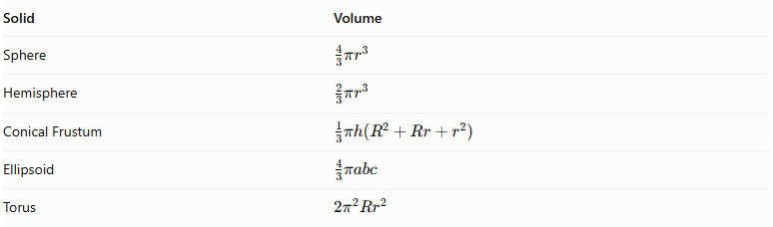
Solid | Volume
Sphere | $$\frac{4}{3}πr^{3}$$
Hemisphere | $$\frac{2}{3}πr^{3}$$
Conical Frustum | $$\frac{1}{3}πh(R^{2}+Rr+r^{2})$$
Ellipsoid | $$\frac{4}{3}πabc$$
Torus | $$2π^{2}{Rr}^{2}$$
Where:
- $R$ = major radius of the torus.
- $r$ = minor radius of the torus.
- $a,b,c$ = ellipsoid's three semi-axes.

Surface Area
# Source: AI Source: Provided by: [Data Path: Persons Table -> ID Column: 1, Name_En Column: Motasem Essam] -> From: [ChatGPT] on [7/25/2026]
The external surface area is the sum of all exposed surfaces. Hidden joining regions must be excluded.
Useful curved surface area formulas:
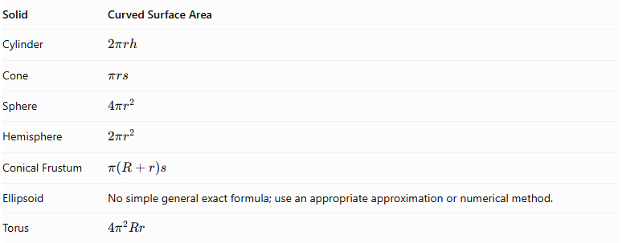
Solid | Curved Surface Area
Cylinder | $$2πrh$$
Cone | $$πrs$$
Sphere | $$4πr^{2}$$
Hemisphere | $$2πr^{2}$$
Conical Frustum | $$π(R+r)s$$
Ellipsoid | No simple general exact formula; use an appropriate approximation or numerical method.
Torus | $$4π^{2}Rr$$
For a composite solid with components joined through complete matching planar faces:
$${SA}_{total}=\sum{{SA}_{i}}-2\sum{A_{joining}}$$
This simplified expression applies when each joining interface is a complete matching planar face and the interfaces do not overlap. For partial or curved contacts, calculate the actual hidden regions separately.
A general expression is:
$$\boxed{{SA}_{external}={SA}_{exposed component surfaces}}$$

Worked Examples

Example 1: Rectangular Prism with a Cylinder and a Cone
# Source: AI Source: Provided by: [Data Path: Persons Table -> ID Column: 1, Name_En Column: Motasem Essam] -> From: [ChatGPT] on [7/25/2026]
Given:
- Rectangular prism: $10×8×6$ cm.
- Cylinder radius: $2$ cm.
- Cylinder height: $4$ cm.
- Cone radius: $2$ cm.
- Cone height: $3$ cm.
- The cylinder is attached to the top of the prism, and the cone is attached to the top of the cylinder.
- Both circular joining faces are completely hidden.
Step 1: Calculate the rectangular prism volume.
$$V_{p}=10×8×6=480$$
Step 2: Calculate the cylinder volume.
$$V_{c}=π(2)^{2}(4)=16π$$
Step 3: Calculate the cone volume.
$$V_{cone}=\frac{1}{3}π(2)^{2}(3)=4π$$
Step 4: Calculate total volume.
$$V=480+16π+4π$$
$$\boxed{V=480+20π≈542.83{ cm}^{3}}$$
Step 5: Calculate the rectangular prism surface area.
$${SA}_{p}=2(10×8+10×6+8×6)$$
$${SA}_{p}=376$$
Step 6: Calculate the cylinder's exposed curved surface area.
$${CSA}_{c}=2π(2)(4)=16π$$
Step 7: Calculate the cone's slant height.
$$s=\sqrt{2^{2}+3^{2}}=\sqrt{13}$$
Step 8: Calculate the cone's curved surface area.
$${CSA}_{cone}=π(2)\sqrt{13}$$
$${CSA}_{cone}=2π\sqrt{13}$$
Step 9: Calculate total external surface area.
The two circular joining regions are hidden. The cylinder's lower base is hidden by the prism, and its upper base is hidden by the cone.
$$SA=376+16π+2π\sqrt{13}$$
$$\boxed{SA≈443.95{ cm}^{2}}$$

Example 2: Cylinder with Two Hemispherical Ends
# Source: AI Source: Provided by: [Data Path: Persons Table -> ID Column: 1, Name_En Column: Motasem Essam] -> From: [ChatGPT] on [7/25/2026]
Given:
- Cylinder radius: $3$ cm.
- Cylinder height: $8$ cm.
- Two hemispheres, each with radius $3$ cm.
- One hemisphere is attached to each circular end of the cylinder.
Step 1: Calculate the cylinder volume.
$$V_{c}=π(3)^{2}(8)=72π$$
Step 2: Calculate the volume of the two hemispheres.
$$V_{h}=2(\frac{2}{3}π(3)^{3})$$
$$V_{h}=36π$$
Step 3: Calculate total volume.
$$V=72π+36π$$
$$\boxed{V=108π≈339.29{ cm}^{3}}$$
Step 4: Calculate the cylinder's exposed curved surface area.
$${CSA}_{c}=2π(3)(8)=48π$$
Step 5: Calculate the curved surface area of two hemispheres.
$${CSA}_{h}=2(2π(3)^{2})=36π$$
Step 6: Calculate total external surface area.
$$SA=48π+36π$$
$$\boxed{SA=84π≈263.89{ cm}^{2}}$$
This example demonstrates a combination of cylindrical and hemispherical curved surfaces. It contains no exposed flat faces because the circular joining faces are hidden.

Important Characteristics
# Source: AI Source: Provided by: [Data Path: Persons Table -> ID Column: 1, Name_En Column: Motasem Essam] -> From: [ChatGPT] on [7/25/2026]
- Mixed Surface Geometry: The solid contains flat surfaces and multiple types of curved surfaces.
- Multiple Components: It is constructed from two or more geometric solids.
- Different Curved Geometries: Components may include cylinders, cones, spheres, hemispheres, ellipsoids, and tori.
- Variable Arrangements: Components can be stacked, attached, nested, or arranged along common axes.
- Complex Joining Regions: Contact regions may be planar, circular, partial, or curved.
- Variable Dimensions: Each component can have different radii, heights, lengths, and other dimensions.
- Volume Calculation: Component volumes are added when their interiors do not overlap.
- Surface Area Calculation: Only exposed surfaces contribute to external surface area.
- Geometric Complexity: Some configurations require advanced geometric methods to calculate intersections and exposed surface areas.

Comparison with Other Surface Combinations
# Source: AI Source: Provided by: [Data Path: Persons Table -> ID Column: 1, Name_En Column: Motasem Essam] -> From: [ChatGPT] on [7/25/2026]
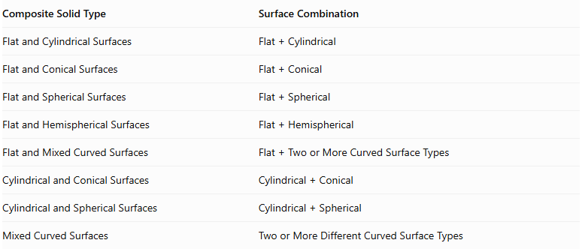
Composite Solid Type | Surface Combination
Flat and Cylindrical Surfaces | $$Flat+Cylindrical$$
Flat and Conical Surfaces | $$Flat+Conical$$
Flat and Spherical Surfaces | $$Flat+Spherical$$
Flat and Hemispherical Surfaces | $$Flat+Hemispherical$$
Flat and Mixed Curved Surfaces | $$Flat+TwoorMoreCurvedSurfaceTypes$$
Cylindrical and Conical Surfaces | $$Cylindrical+Conical$$
Cylindrical and Spherical Surfaces | $$Cylindrical+Spherical$$
Mixed Curved Surfaces | Two or More Different Curved Surface Types

Applications
# Source: AI Source: Provided by: [Data Path: Persons Table -> ID Column: 1, Name_En Column: Motasem Essam] -> From: [ChatGPT] on [7/25/2026]
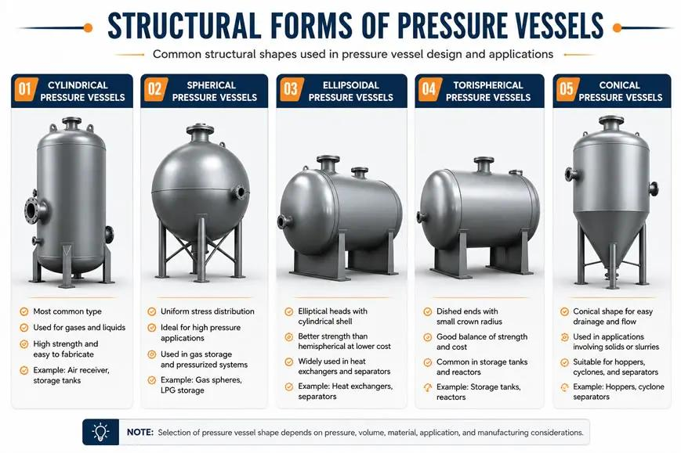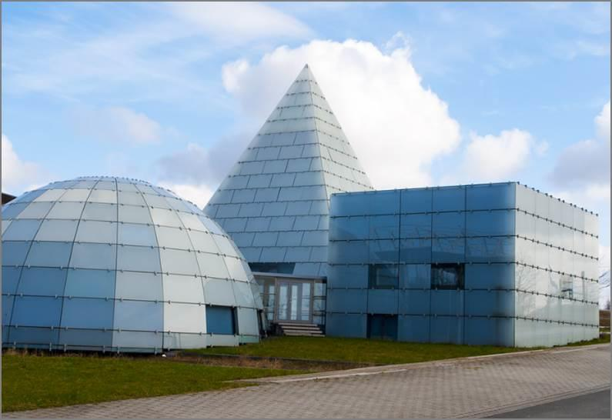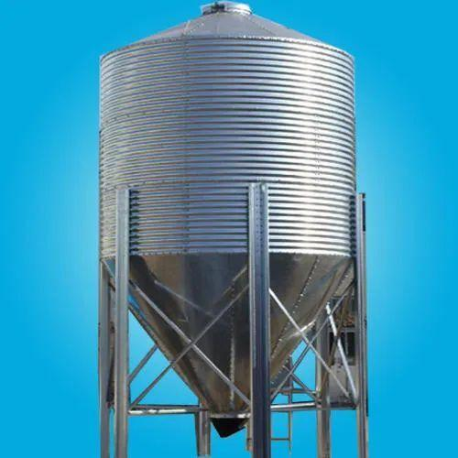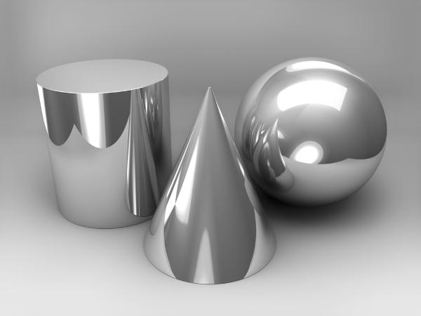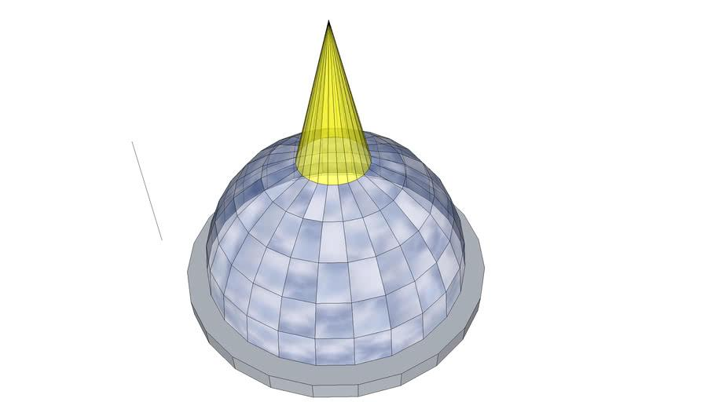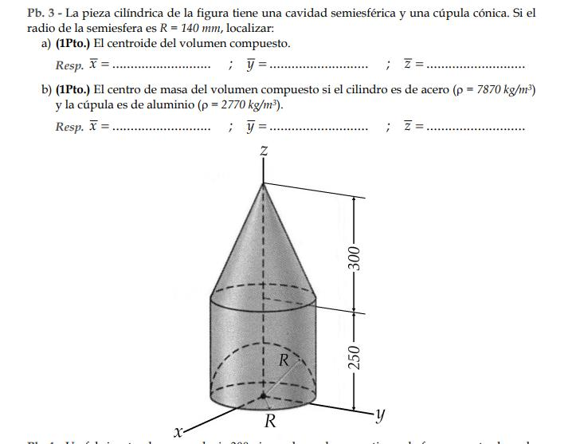
- Architecture: Buildings combining rectangular structures, cylindrical towers, and spherical or conical roofs.
- Industrial Engineering: Storage tanks, pressure vessels, hoppers, and processing equipment.
- Mechanical Engineering: Machine components combining cylindrical, conical, and spherical geometries.
- Product Design: Products with flat supporting bases and multiple curved components.
- Construction: Structures combining domes, cylindrical columns, and conical sections.

Key Points
# Source: AI Source: Provided by: [Data Path: Persons Table -> ID Column: 1, Name_En Column: Motasem Essam] -> From: [ChatGPT] on [7/25/2026]
- These composite solids combine flat surfaces with two or more types of curved surfaces.
- Curved components may include cylinders, cones, spheres, hemispheres, ellipsoids, and tori.
- They can be classified according to their curved surface combinations and component arrangements.
- Volume is calculated by combining component volumes while avoiding double-counting.
- External surface area includes only exposed surfaces.
- Hidden joining regions must be excluded.
- Complex intersections may require advanced geometric calculations.

Conclusion
# Source: AI Source: Provided by: [Data Path: Persons Table -> ID Column: 1, Name_En Column: Motasem Essam] -> From: [ChatGPT] on [7/25/2026]
Composite Solids with Flat and Mixed Curved Surfaces are three-dimensional structures that combine planar faces with multiple types of curved surfaces. They can be constructed from different combinations of prisms, cylinders, cones, spheres, hemispheres, ellipsoids, and tori.
Their geometric analysis requires identifying each component, calculating its volume, and determining which surfaces remain exposed after the components are joined.

